**First API Request**

**Step 1:** Setting upAPI request on Postman

Create a Workspace

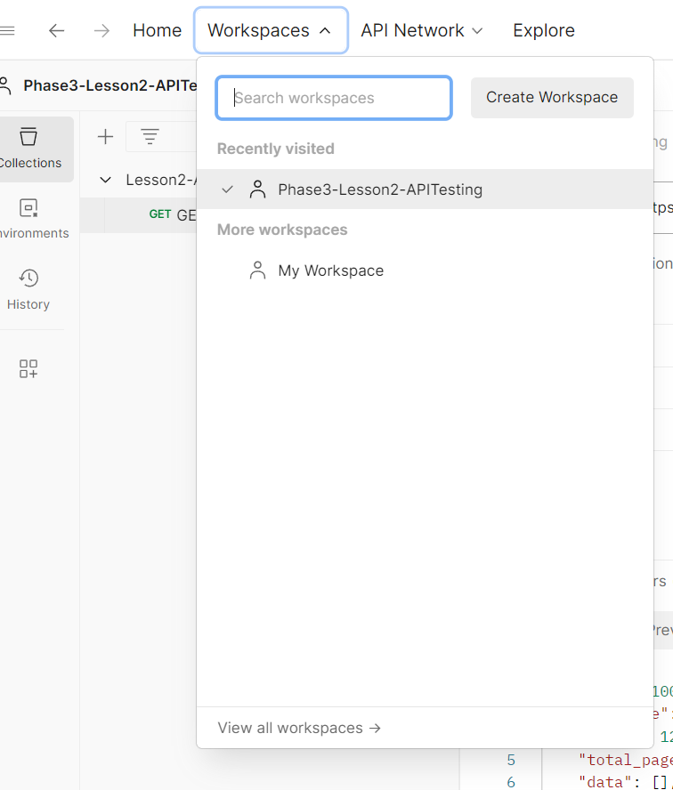

Click on next

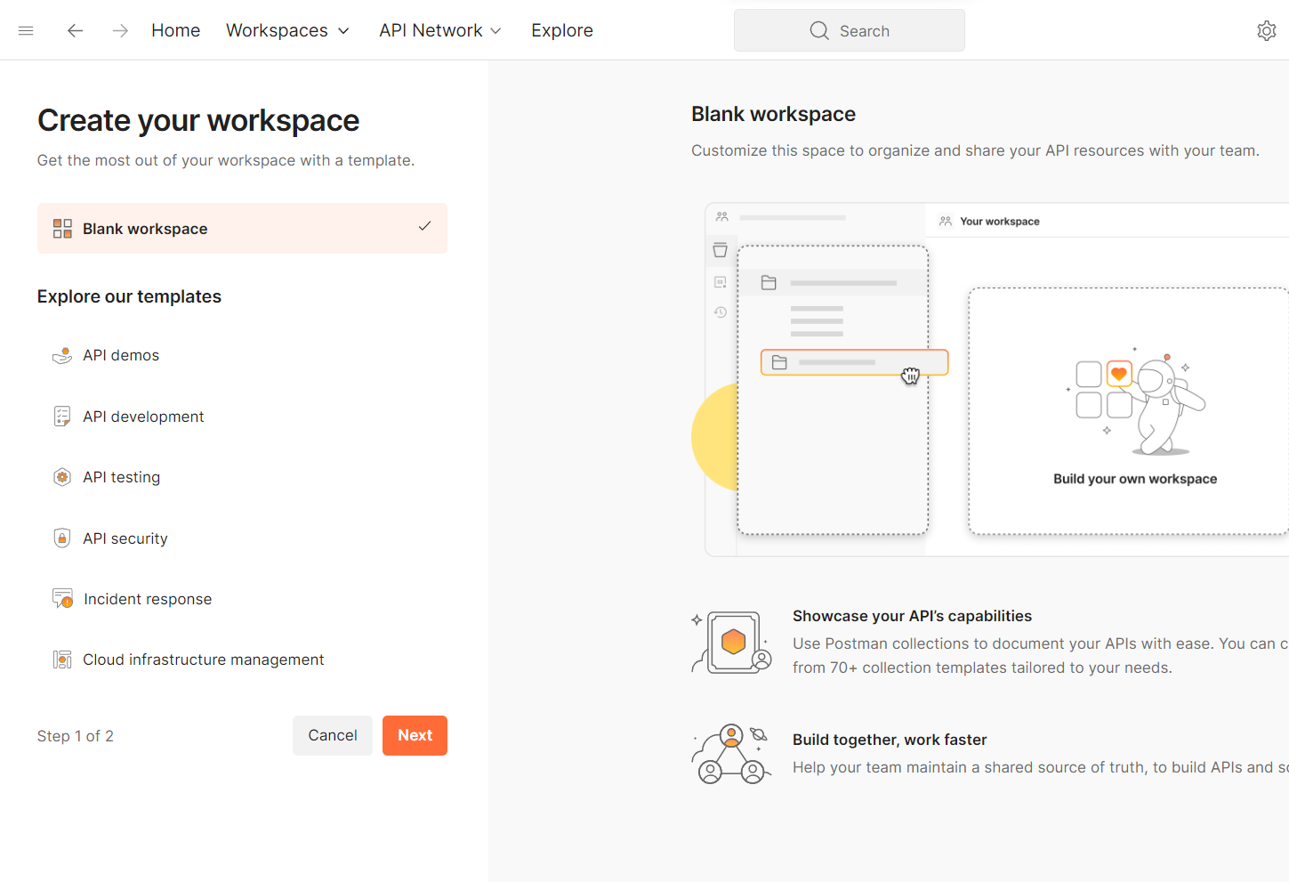

Fill in details and click on create

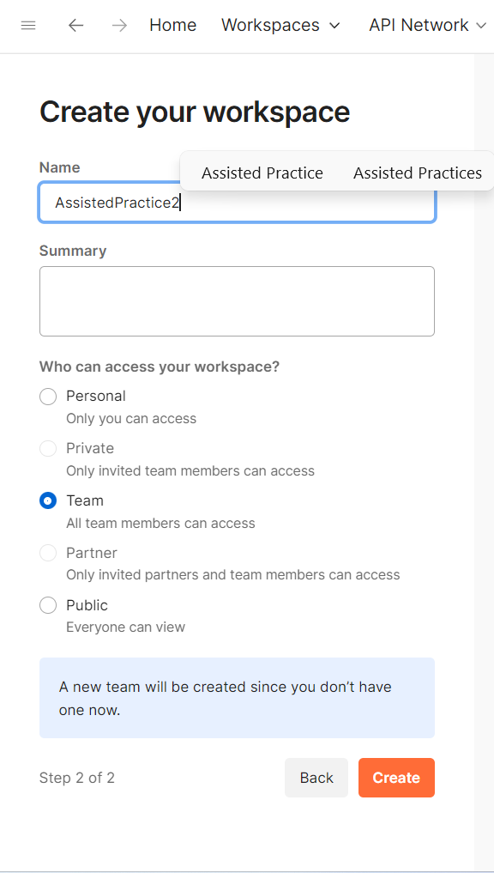

Add a request and give an URL click on send

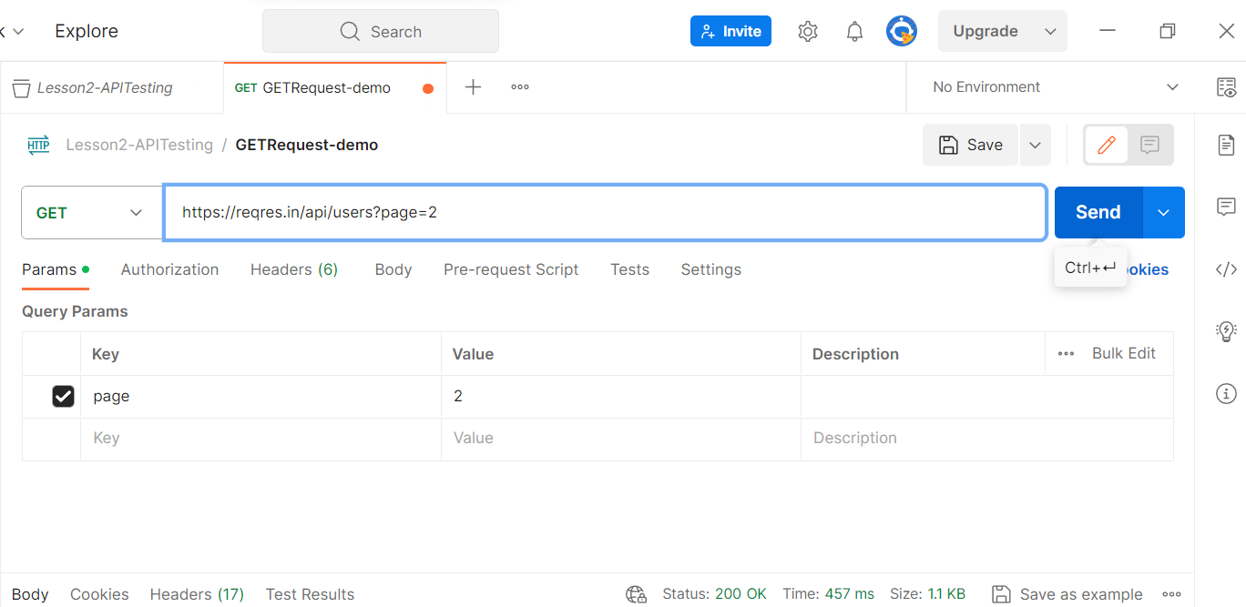

**Step 2:** Getting a response of API request on Postman

